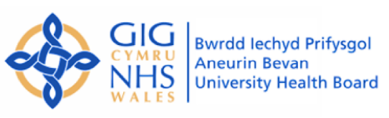
Clinical Guideline
MODIFIED PARVOLEX® (NAC/ACETYLCYSTEINE) REGIMEN 12-hour regimen (known as the Scottish and Newcastle Acetylcysteine Protocol; SNAP)

SETTING | Paediatric Emergency Department
FOR STAFF | All staff
ATTENTION | ALL cases for above regimen MUST be discussed with a Senior Clinician (ST4 and above) and documented in the notes
PATIENTS | Patients requiring treatment with Parvolex® (acetylcysteine) for paracetamol overdose
There is NO CHANGE to the initial management of paracetamol overdose including indications for treatment with parvolex. Please refer to Toxbase guidelines https://www.toxbase.org/poisons-index-a-z/p-products/paracetamol------------/

- Administration of Parvolex® has changed as well as subsequent management.
- Infusion to be administered in 2 consecutive bags rather than 3
- Contains same drug with same total dose of acetylcysteine
- Given over 12 hours rather than 21 hours
- Equally as effective but with shorter duration and less adverse effects
- Please note- this guidance is found on Toxbase
- At the end - take repeat bloods (INR, LFTs, U+E, FBC, Paracetamol level) 2 hours before end of second bag.

https://www.toxbase.org/poisons-index-a-z/s-products/snap-acetylcysteine---antidote/
and click “1. Modified 12-hour regimen (known as the Scottish and Newcastle Acetylcysteine Protocol; SNAP)” for the infusion guidelines.

https://www.toxbase.org/Information/miscellaneous/Paracetamol/Paracetamol---Guidance-on-when-to-take-bloods-and-interpretation-of-these-results-at-the-end-of-the-modified-12-hour-acetylcysteine-infusion-regimen-SNAP/

Important
Toxbase- First Infusion
Note that the 200 mL bags of 5% glucose or sodium chloride 0.9% required for the first infusion are not currently commercially available. For this infusion, the excess amount of fluid should be removed from a larger bag using a syringe and discarded, before adding the acetylcysteine, e.g. by removing and discarding 50 mL from a 250 mL infusion bag.

Table A
REFERENCES | Reduction of adverse effects from intravenous acetylcysteine treatment for paracetamol poisoning: a randomised controlled trial
RELATED  DOCUMENTS AND PAGES | Toxbase paracetamol guidelines
SUPPORTED BY | Paediatrics, Pharmacy, Biochemistry and MTC
SAFETY | This regimen is not licensed or endorsed by the MHRA. In view of its unlicensed status, use should be endorsed by a senior clinician.
QUERIES AND CONTACT | Duty Consultant/registrar overnight

