The Grange University Hospital

Guide to Paediatric Anaphylaxis

Co-Authors: Dr Emily Ball, Dr Grace Mckay, Dr Rhianwen Quarry
Contents
 |  | Page
Overview | Definition | 3
 | Recognition | 3
 | Triggers | 3
Management | Algorithm | 4
 | Drug doses | 5
 | Biphasic Reaction | 5
 | Investigation | 5
 | Documentation | 6
 | Observation | 6
Discharge & Follow up | Adrenaline Auto Injectors | 7
 | Patient Information | 7
 | Allergy Plan | 8
 | Allergy Nurses | 8
 | Outpatient Clinic | 8-9
Discharge Checklist |  | 10
References & Resources |  | 11
Contact Details |  | 12

KEY POINTS
- Anaphylaxis is life threatening, use an ABCDE approach, call for senior help early, and reassess regularly.
- If in doubt give adrenaline.
- All children with anaphylaxis should be admitted for observation.

Overview
DEFINITION
Anaphylaxis is a severe, life-threatening, generalised or systemic hypersensitivity reaction. It is characterised by rapidly developing life-threatening airway and/or breathing and/or circulation problems and usually associated with skin and mucosal changes ¹.

RECOGNITION
Anaphylaxis is likely when all 3 criteria are met ²:
● Sudden onset and rapid progression of symptoms.
● Life-threatening Airway and/or Breathing and/or Circulation.
● Skin or mucosal changes (flushing, urticaria, angioedema)
Exposure to a known allergen supports the diagnosis.

TOP TIPS FOR RECOGNITION: ²
- The variability of features can make anaphylaxis difficult to diagnose.
- Reactions usually begin within minutes and rapidly progress, but can occur 2-3 hours later.
- Skin or mucosal changes alone are not a sign of anaphylaxis.
- Skin and mucosal changes can be absent in 20% of reactions.
- Gastrointestinal symptoms are common (e.g. vomiting, abdominal pain, diarrhoea).

TRIGGERS
- Food allergy e.g. peanuts, milk/dairy, egg, wheat, fish/seafood, sesame and soya). These are the most common causes in children (2).
- Medicines (e.g. antibiotics, NSAIDS)
- Latex
- Insect Stings
- Others: Exercise, idiopathic, monoclonal antibody therapies.

Management
DRUG DOSES
*we advise prescribers to check all doses in the BNFc*
Drugs | <6 months | 6 mo - 6 years | 6-12 years | >12 years
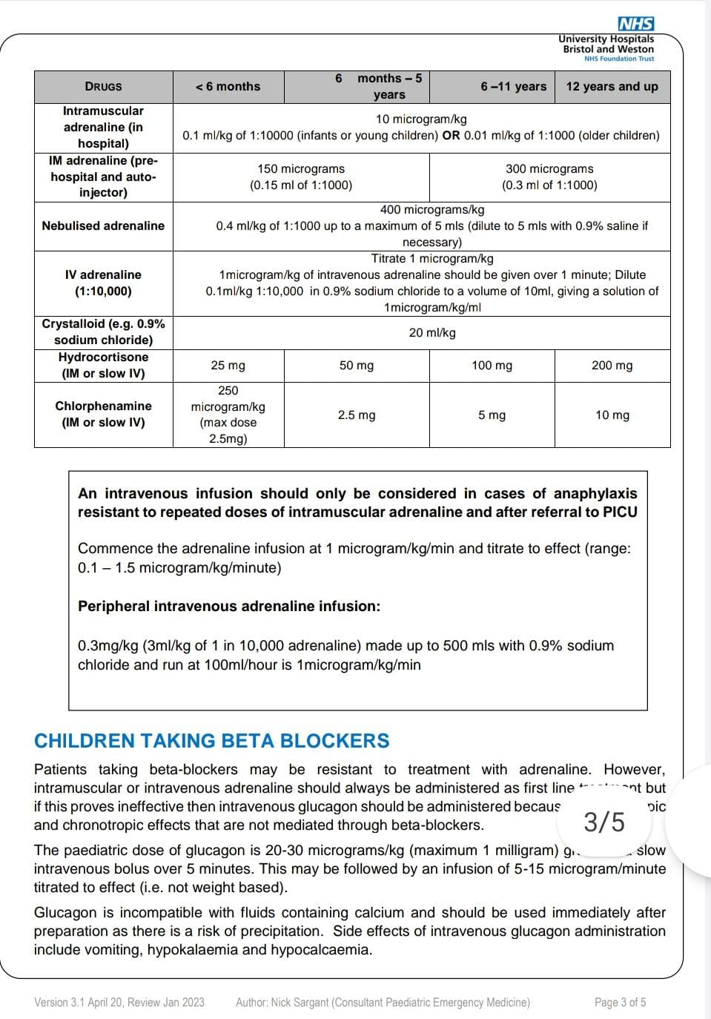BIPHASIC REACTION
After complete recovery of anaphylaxis, a potential recurrence of symptoms can occur within 72 hours despite no further exposure to the allergen. It is managed in the same way as anaphylaxis.

INVESTIGATIONS
Mast Cell Tryptase (MCT)

Mast cells are granulocytes located in the peripheral tissues which ‘degranulate’ in response to various physiological stimuli including trauma, high temperature, and allergens (3). When Mast cells degranulate, they release a number of inflammatory mediators, one of which is MCT.

MCT is a protease enzyme that has a role in inflammation ³. Serum MCT levels are measured to distinguish anaphylactic reactions from other systemic disturbances which may present with similar clinical manifestations ³.

Nb. MCT is not always elevated when food is the allergen or when the main presenting feature is respiratory ⁴.

NICE recommends measuring MCT in children <16 years old when anaphylaxis is thought to be caused by venom, drugs or ‘unknown’ ⁴.

In GUH, obtain a serum MCT sample into a Yellow (or Purple) top bottle.
- 1st sample as soon as possible (after emergency treatment).
- 2nd sample within 1–2 hours (max 4 hours) from onset of symptoms.
- Inform the patient and parent/carer that another sample may be required at follow up.

DOCUMENTATION
In all patients who have suspected anaphylaxis, record the following in their clinical notes ⁴:
- The circumstances immediately before onset of symptoms (to identify a possible trigger)
- The time of onset of the symptoms.
- The acute clinical features of the reaction. (eg. rapid, life-threatening ABC problems, associated skin and mucosal changes).

OBSERVATION

All children who have emergency treatment for suspected anaphylaxis should be admitted for observation under the Paediatric team ⁴.

- Patients who present with respiratory compromise require monitoring for 6-8 hours ⁵.

- Patients who present with circulatory instability require monitoring for 12-24 hours ⁵.

Discharge and Follow up

ADRENALINE AUTO INJECTOR (AAI)
Who should be prescribed an AAI?
Risk assessment is essential to inform the need for an AAI. This should include an assessment of the severity of the reaction and the likelihood of recurrence. Co-factors leading to severe reactions and geographic issues should be considered ⁶.

How many AAIs do I prescribe?
The UK’s Medicines and Healthcare Products Regulatory Agency (MHRA) advises that anyone at risk of anaphylaxis should have at least two AAI devices immediately available ⁶.

In some cases, a single injection is not sufficient to achieve a response and a second injection is needed ⁶.

Training for AAI
It is the responsibility of the prescribing clinician to ensure that adequate training is provided when an AAI is prescribed ⁶.
Training should include:
- The circumstances in which an AAI needs to be administered
- How to use the particular type of AAI device.
- Training of the patient and their parents/carers.
- Training of childcare and education professionals.

In GUH, we prescribe AAIs generically (EpiPen® is usually in stock)

In hours, AAI training is provided by Paediatric Nurses

Out of hours, AAI training can be accessed by (this video)

PATIENT INFORMATION
Provide the patient with ‘Basic Avoidance Advice’ by specifying which allergens need to be avoided (if known).
Provide the patient with one of the following Patient Information Leaflets

ALLERGY PLAN
All patients should be provided with an ‘Allergy Plan’ to provide advice on what to do if an anaphylactic reaction occurs ⁷.

In GUH, we use the British Society for Allergy & Clinical Immunology (BSACI) allergy plan ⁷.
Download and print this BSACI Allergy Plan
Complete and give to the patient on discharge
Ensure enough copies are provided so they are accessible in all childcare settings (eg. school, home, childminder etc.)

ALLERGY NURSES
In GUH, children presenting with ANAPHYLAXIS must be referred to the allergy nurses for support. This can be done by emailing ABB.PaedsRespiratoryNurse@wales.nhs.uk

OUTPATIENT ALLERGY CLINIC
Which patients do I refer?
In GUH, the criteria for referral to Allergy Outpatient Clinic includes:
- All anaphylaxis
- Tree nut allergy (Acorns, Almonds, Brazil, Walnuts, Cashew, Hazelnut)
- Allergy and asthma
- Multiple food allergies
- Diagnostic dilemmas

Nb. Food allergies such as egg, milk or peanut are referred to the General Paediatric Outpatient Clinic.

How do I refer?
To refer patients to the Allergy Outpatient Clinic

Paeds: complete the CWS discharge letter → free type ‘For Allergy OPC’ and create a CWS e-referral to paediatrics → free type ‘For Allergy OPC’

ED: complete a CWS e-referral to paediatrics → free type ‘For Allergy OPC’

Which consultant?
The following consultants are Paediatric Allergy Specialists:
- Dr Jyotsna Vaswani (secretary 01633234556)
- Dr Nakul Gupta (secretary 01873732479)
- Dr Marcus Pierrepoint (secretary 01873732912)
When will the patient receive an appointment?
The patient will receive a letter notifying them of their allergy appointment within approximately 8 weeks.
If by 8 weeks they have not been contacted, advise the patient to contact the booking centre 01495765055, select option 3, and speak to Elise Davies.
Alternatively advise to contact the Paediatric Secretaries directly.

Paediatric Anaphylaxis Discharge Checklist

Prior to discharging a patient with treated anaphylaxis please ensure that you have completed the following:

- Documented possible triggers in the GP discharge summary
- Prescribed 2 Adrenaline Auto Injectors (EpiPen®)
- Explained this EpiPen® Training video
- Printed this Allergy Plan for the patient to take home
- Provided this Allergen Avoidance Advice to the patient
- Provided the relevant one of these Patient Information Leaflets
- Booked Follow up in the Outpatient Allergy Clinic (if applicable)
- Referred to Allergy Nurse (if applicable)

References
- European Academy of Allergy and Clinical Immunology. 2021. [Online]. [Accessed on 26th October 2021]. Available from: www.eaaci.org
- Resuscitation Council. 2021. Emergency Treatment of Anaphylaxis Guidelines for Healthcare Providers. London: Resuscitation Council UK.
- Pane, V. and Kam, P. 2004. Mast cell tryptase: a review of its physiology and clinical significance. Journal of Anaesthesia. 59(1). pp. 695–703.
- National Institute of Clinical Excellence NICE. 2020. Clinical Guideline:CG134 - Anaphylaxis: assessment and referral after emergency treatment. NICE.

European Academy of Allergy and Clinical Immunology Anaphylaxis Multidisciplinary Task Force. 2021. EAACI guideline: Anaphylaxis (2021 update). London: John Wiley and Sons Ltd.
- Medicines and Healthcare Products Regulatory Agency (MHRA). 2017. Drug Safety Update. 11(1) [Online]. [Accessed on 26th October 2021]. Available from: www.gov.uk/drug-safety-update/adrenaline-auto-injectors-updated-advice-after-european-review
- British Society for Allergy & Clinical Immunology (BSACI). 2021. [Online]. [Accessed on 26th October 2021]. Available from: www.bsaci.org/guidelines/bsaci-guidelines

Resources

www.allergyuk.org
www.anaphylaxis.org.uk
www.allergynorthwest.nhs.uk - with special thanks for permission to use patient information leaflets and resources

Contact Information

If you have any comments, queries, or suggestions regarding this guide then please contact jyotsna.vaswani@wales.nhs.uk, Consultant Paediatrician and Allergy Specialist at the Grange University Hospital.

Authors:

Dr Emily Ball ST4 Paediatric Medicine
Dr Grace McKay ST4 Emergency Medicine
Dr Rhianwen Quarry ST3 Emergency Medicine

This is Version 1.0 January 2022
Proposed date for review May 2026

