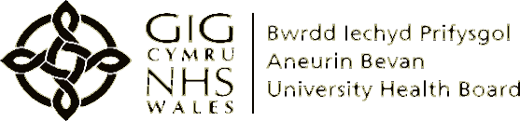

Single Point of Access for

Neuro-developmental (ND) Referrals
Information for Families and Professionals

What is the ND Referral Pathway?
The ND Referral pathway has been developed to provide a single point of access for all- Gwent referrals for children and young people aged 0 – 18 years regarding neuro-developmental concerns including autistic spectrum disorder (ASD) or attention deficit hyperactivity disorder (ADHD).

How is a referral processed within the ND Referral Pathway?
Once received, a referral will undergo a series of checks to ensure that there is sufficient information for it to be processed. The ND Referral Pathway is facilitated by the Community Embedded ND (CET/ND) Triage Team within the Child and Adolescent Mental Health Services (CAMHS). The triage team will consist of professionals from Paediatrics and the Neuro-Developmental Team. The Team is multi-disciplinary and includes Nursing, Therapies and Medical staff who will review each referral and make a decision on the most appropriate outcome to meet the needs of the child / young person and their family. Based on the outcome of the review, appropriate referrals will be made to the Community Embedded Team, ND Assessment Team, Integrated Services for Children with Additional Needs (ISCAN) Panel, Single Point of Access Children’s Emotional (SPACE) Wellbeing / Early Help Panel and others services to provide a seamless referral process.

Who can make an ND Referral?
Professionals who have a good understanding of the child or young person.

How do I make a referral into the ND Referral Pathway?
A referral form is to be completed and submitted to the single point of contact email address: ABB.SPACEWellbeingND@Wales.nhs.uk

Informed consent must have been gained from a person with parental responsibility and / or the young person where appropriate or verbal consent may be given via the professional making the referral.

Information that is recorded during the referral process will be stored within ABUHB secure electronic files and used for the purpose of providing services to children, young people and their families.

If you have any queries or require a referral form,
please contact the Community Embedded Team on 07583 122831

