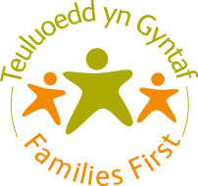
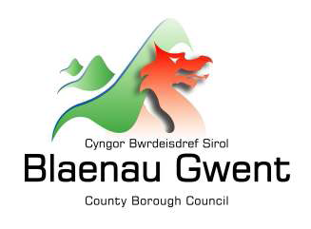
Ref No.

Together Everyone Achieves More
Cyflawni Mwy Gyda’n Gylydd
Blaenau Gwent Families First/SPACE Wellbeing
Request for Support Form
Type of Request: |  |  | Initial Request  Self-Request  Re-request |  |  |  | Step Down Request  Space Wellbeing  Is the family remaining open to SSD? Y/N  Please attach Integrated Assessment/last Care & Support Plan
Family Name/Names:
Address:
Telephone Number/s:
Previous Addresses:
Previous JAFF Assessment: |  |  |  |  | Yes |  |  |  | No
Is this a Flying Start Family: |  |  |  |  | Yes |  |  |  | No
Does any family member have needs relating to a disability? |  |  |  |  | Yes |  |  |  | No
Family affected by imprisonment? |  |  |  |  | Yes |  |  |  | No
Details of person making the request for support
Name of Agency:
Name & Contact Details of Worker:
Worker’s Signature
Date of Completion
I understand that the information in this form will be added to the Families First database and may be shared with other service providers in order to meet my needs. This database is used by Families First for administration, service delivery and monitoring and evaluation.
I understand that the data will be stored and shared in accordance with the Data Protection Act 1998.
Has informed consent been obtained from the Family/Young Person/Child to make this request:
Yes: Verbal: Written:

No: If not, why not:

Brief Summary of Family Circumstances:
Reason for Request for Support/Support Required:

If this is a request for support from SPACE Wellbeing please complete the following:-

What help is the family expecting?

What is your opinion on presentation and expectation of this request
What is your understanding of child/young person/family’s presenting issues? What are you expecting from making this request for support? If available, please include relevant findings from education, social care, and/or other health examinations or assessments

What has already been tried to address the child’s or young person concerns
(Please include both self-help and support from professionals. Please indicate what has been helpful or unhelpful)

Are there any risks associated with this family that Services should be aware of? | YES | NO
Additional information relating to Risk (Include safeguarding; personal safety, e.g. suicide / self-harm; risks to professionals, e.g. risks in the home environment)

WCCIS  Number | Status Within Family (e.g. Mother) | Surname |  | First Name |  |  |  | DOB |  | Gender  (M/F) |  | Ethnicity | Household Members  Y/N

Families First Office Use Only
Outcome/Decision:

Signature:

Date:

Please return form marked CONFIDENTIAL to:
Blaenau Gwent Families First Team
Heart of the Valleys Integrated Children’s Centre
High Street
Blaina
Blaenau Gwent
NP13 3BN
Email: familiesfirstduty@blaenau-gwent.gov.uk
Telephone: 01495 355584

