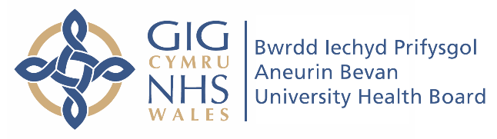
Community Childrens Nursing Service
Care Closer to Home (CCTH)

Care Closer To Home
C

Care Closer to Home

Parent Information Leaflet

You have received this leaflet as a referral has been made for your child to receive nursing support from the Care Closer to Home (CCTH) team. You will have been provided with a written advice leaflet or website information with further information about your child’s condition and what to expect over the next few days.
The CCTH is part of the Community Children’s Nursing Service and provides short term nursing care to children and young people within the community. The CCTH team will make contact with you in the next 18 hours (if referred after 6pm, you will be contacted the next day). However, if, after reading this information, you have any concerns about your child within the next 48hrs then please contact the CCTH team on either 01633 748056 (CCTH South team) or 01443 802283 (CCTH North team) between 9am-5pm, or the hospital department that your child was discharged from outside of these hours. Children’s emergency assessment unit: 01633 493138 /children’s ward: 01633 493609 (delete as appropriate)
The CCTH team offers nursing support around the management of minor illnesses and administration of intravenous medication. This may prevent your child being admitted or enable earlier discharge from hospital.
A member of the team will contact you for either a telephone review or to arrange an appointment - this may take place at your home or another community location such as a children’s centre.
CCTH Hours of Service: Between 9 am – 8 pm weekdays and 10 - 6 on weekends
If you have a concern and are unable to contact the CCTH team, please contact the children’s ward/CEAU.

