15. Eating Disorders

Background

Relatively common – 0.5-0.7% adolescent females have anorexia nervosa, 5-10% of eating disorders occur in males.
Anorexia nervosa associated with significant morbidity and 5% mortality.
Incidence increasing in younger children, where there is less predominance of female cases

Early recognition and management generally result in better outcomes.

Children may be referred to the Assessment Unit by colleagues in the Child and Family Psychological Health Service for a physical health assessment, or they may be referred by the GP, or during assessment of other issues it may become apparent the child or young person has a potential eating disorder.

Diagnostic criteria used in adults, particularly for anorexia, are not fully applicable to children and adolescents whose weight may not fall to 85% ideal weight, and who may be pre-pubertal and therefore not attained menarche.

NB. Adolescents can present with eating disorders at ‘normal’ body weights/ BMI, especially if there is a history of preceding obesity.

History
Weight – ask about duration and degree of weight loss, and whether trying to reach any target weight. Is anyone else (friends, teachers, parents) concerned about their weight?
Diet – 24 hour diet history, whether avoiding any food groups, calorie counting, and history of bingeing or vomiting after meals. Include history of fluid intake.
Pubertal development – age at menarche, regularity of periods, LMP
Exercise – how frequent, what intensity?
Systems review – dizziness, syncope, cold intolerance, hair loss, easy bruising, constipation, abdominal pain, palpitations, poor concentration, tiredness
Family history – obesity, eating disorder, psychiatric illness
Other – any thoughts or history of self harm, substance misuse. Consider using HEADSSS assessment.

Examination
Accurate weight and height, plotted on growth chart
Plot BMI on growth chart (see instructions on new 2012 growth charts for doing this).

If plotting on 2nd centile or less, calculate percentage median BMI.
Percentage BMI = actual BMI (weight/height²) x 100
Median BMI (50th percentile) for age & gender

General physical examination, paying particular attention to;

- Temperature, hydration status, skin & hair
- Cardiovascular system – bradycardia, cool peripheries, blood pressure, postural hypotension, arrhythmias
- Signs of recurrent vomiting - gingivitis, dental caries, swollen parotid glands, callouses on hands, loss of tooth enamel
- Pubertal development – prepubertal, entering puberty or completing puberty (see 2012 growth charts for definitions)
- Signs to suggest alternative diagnosis – lymphadenopathy, mouth ulceration, abdominal tenderness or mass, hepatosplenomegaly

Please fill in the following check lists and attach to notes (page 244/245)

Paediatric Checklist for Patients Admitted for Refeeding in Anorexia Nervosa

Please place in notes at time of admission

Calculate BMI _______kg/m²

Baseline bloods taken
(FBC, U&E, LFT, TFT, bone profile, magnesium, glucose, vitamin D)

ECG performed

Prescribe Forceval 1 capsule daily

Prescribe Phosphate Sandoz 1 tablet twice daily
(If phosphate level low initially this may need to be increased)

Inform dietician

Daily bloods - (U&E, bone profile, magnesium)
Day 1
Day 2
Day 3
Day 4
Day 5
Day 10-12 (if still an inpatient)

Lying/standing blood pressure, at least daily
(In addition to routine observations)

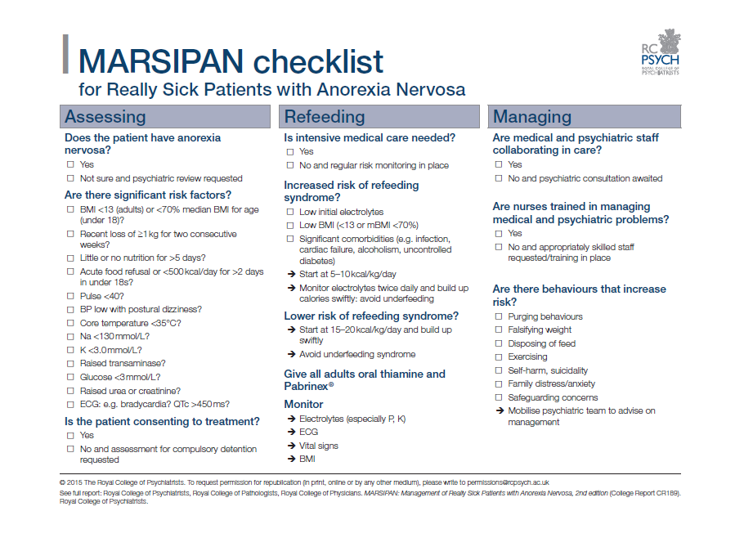
The Junior MARSIPAN report provides a framework for the medical assessment of risk;
Risk assessment framework for young people with eating disorders
 | Red | Amber | Green | Blue
BMI & weight | Percentage median  BMI<70% (approx.  below 0.4th BMI centile)  Recent loss of weight of 1 kg or more/week for 2 consecutive weeks | Percentage  median BMI 70–80% (approx. between 2nd and  0.4th BMI centile)  Recent loss of weight of 500– 999 g/week for 2 consecutive weeks | Percentage median BMI 80–85% (approx.  9th–2nd BMI centile)  Recent weight loss of up to  500 g/week for 2 consecutive weeks | Percentage median BMI>85% (approx. above 9th BMI centile)  No weight loss over past 2 weeks
Cardiovascular health | Heart rate (awake)<40  bpmª  History of  recurrent syncope; marked orthostatic changes (fall in systolic blood pressure of  20 mmHg or more, or below 0.4th– 2nd centiles for age, or increase  in heart rate of >30 bpm)  Irregular heart rhythm (does  not include sinus arrhythmia) | Heart rate (awake) 40–50 bpm  Sitting blood pressure: systolic <0.4th centile (84–98 mmHg depending  on age and gender^{b}); diastolic  <0.4th centile (35–40 mmHg depending on age and gender  Occasional syncope; moderate orthostatic cardiovascular changes (fall in systolic blood pressure of  15 mmHg or more, or diastolic blood pressure fall of 10 mmHg or more within  3 min standing, or increase in  heart rate of up to 30bpm | Heart rate (awake) 50– 60 bpm  Sitting blood pressure: systolic <2nd centile (98–105 mmHg depending  on age and gender^{b}); diastolic  <2nd centile (40–45 mmHg depending on age and gender  Pre-syncopal symptoms but normal orthostatic cardiovascular changes  Cool peripheries; prolonged pe- ripheral capillary  refll time (normal central capillary  refll time) | Heart rate (awake) >60bpm  Normal sitting blood pressure for age and gender with reference to centile charts  Normal orthostatic cardiovascular changes  Normal heart rhythm
Temperature | Tympanic<35.5°C, axillary <35.0°C | <36°C
Hydration status | Fluid refusal  Severe dehydration (10%): reduced  urine output, dry mouth, decreased skin turgor, sunken eyes, tachypnoea,  tachycardia^{c} | Severe fluid restriction  Moderate dehy- dration (5–10%): reduced urine out- put, dry mouth, normal skin turgor, some tachypnoea, some tachycardia^{c}, peripheral oedema | Fluid restriction Mild dehydration  (<5%): may have dry mouth or not clinically dehy- drated but with concerns about risk of dehydration  with negative fuid balance | Not clinically dehydrated
ECG abnormalities | QTc>460 ms (girls) or 400 ms (boys) with evidence of bradyarrhythmia  or tachyarrhythmia (excludes sinus bradycardia and sinus arrhythmia); ECG evidence  of biochemical abnormality | QTc>460 ms (girls) or 400 ms (boys) | QTc<460 ms (girls) or 400 ms (boys) and taking medication  known to prolong QTc interval, family history of prolonged QTc  or sensorineural deafness | QTc<460 ms (girls) or 400 ms (boys)
Disordered eating behaviours | Acute food refusal or estimated calorie intake 400–600 kcal per day | Severe restriction (less than 50% of required intake), vomiting, purging with laxatives | Moderate restriction, bingeing
Activity and exercise | High levels of uncontrolled exercise in the context of malnutrition  (>2 h/day) | Moderate levels of uncontrolled exercise in the context of malnutrition  (>1 h/day) | Mild levels of uncontrolled exercise in the context of malnutrition  (<1 h/day) | No uncontrolled exercise
Biochemical abnormalities | Hypophosphataemia <0.5mmol/l, hypokalaemia <2.5mmol/l, hypoalbuminaemia, hypoglycaemia <2.5mmol/l, hyponatraemia <130mmol/l, hypocalcaemia | Hypophosphataemia, hypokalaemia, hyponatraemia, hypocalcaemia
Engagement with management plan | Violent when parents try to limit behaviour or encourage  food/fuid intake, parental violence  in relation to feeding (hitting, force feeding) | Poor insight into eating problems, lacks motivation to tackle eating problems, resistance to changes required to gain weight, parents unable to implement meal plan advice given by healthcare providers | Some insight into eating problems, some motivation to tackle eating problems, ambivalent towards changes required to gain weight but not actively resisting | Some insight into eating problems, motivated to tackle eating problems, ambivalence towards changes required to  gain weight  not apparent in behaviour
a. Patients with inappropriately high heart rate for degree of underweight are at even higher risk (hypovolaemia). Heart rate may also be increased purposefully through the consumption of excess caffeine in coffee or other drinks.
b. Jackson et al, 2007.
c. Or inappropriate normal heart rate in an underweight young person.

Differential diagnosis
Diagnosis of eating disorders relies on evidence of abnormal eating behaviour plus disordered thinking and beliefs about weight and body shape. If these abnormal beliefs and behaviours are not present then alternative diagnoses should be considered including;
- Gastrointestinal – inflammatory bowel disease, malabsorption, coeliac disease
- Malignancy – leukaemia, lymphoma, intracerebral tumour
- Endocrine – diabetes, hyperthyroidism, hypopituitarism, Addison’s disease
- Chronic infection – TB, HIV
- CNS disease
- Other psychiatric disorders: depression, OCD

Investigations
- FBC (anaemia, leucopoenia & thrombocytopenia can all occur in anorexia)
- U&E (low creatinine can occur due to low muscle mass & high urea due to catabolic state, rather than dehydration, but high creatinine can be seen if muscle breakdown. So results must be interpreted in light of clinical assessment)
- LFT (mildly raised bilirubin & liver enzymes are not uncommon)
- Bone profile, Magnesium, Glucose
- Vitamin D level
- TFT
- ECG
- Urinalysis – consider pregnancy test if amennorhoeic (with patient’s consent)

Management

Refer to shared care protocol for further information and referral form to CAMHS
http://howis.wales.nhs.uk/sitesplus/866/page/48555

The need for admission to the paediatric ward should be based on history, examination and use of the Junior MARSIPAN risk assessment framework. No one factor predicts risk better than others. Admission should be considered for any young person with ‘red’ alerts on the assessment framework, but may also be needed for those with lower levels of risk depending on the circumstances.

Do not discharge home any young person with ‘red’ alerts on the assessment framework without discussing the patient beforehand with a senior paediatrician (specialty trainee ST4 or above, or a consultant).

At RGH, please inform Dr Morgan’s secretary on extension 8811 if a child or young person is admitted with an eating disorder or potential eating disorder.
For GP referrals or new presentations referral to CAMHS should be made using relevant referral form (available on shared care protocol)

Inform paediatric dieticians of admission
Commence multivitamin supplement egg. Forceval 1 tablet daily
All young people admitted for re-feeding should be commenced on oral phosphate supplements, even if baseline phosphate level is normal. Please prescribe Phosphate Sandoz (each tablet contains 16.1mmol of phosphate) 1 tablet twice daily for first 5 days.

NB. This dose may need to be increased if baseline phosphate low or phosphate level drops on re-feeding.

Daily bloods for at least first 5 days of re-feeding, to include U&E, bone profile, magnesium

Management of other electrolyte abnormalities
1. Hypokalaemia – If K <3.5mmol/l give Sando K (each tablet contains 12mmols of potassium) 2-4 tablets daily
- If K < 3.0mmol/l consider need for intravenous KCl added to intravenous fluids (DO NOT EXCEED 0.4mmol/kg/hour). Admit to HDU, ECG monitoring
2. Hypomagnesaemia (serum Mg <0.6mmol/L) Correct with 0.2ml/kg 50% Magnesium sulphate (max 10ml) in 250ml 0.9% saline over 4 hours. Admit to HDU. Must monitor ECG & blood pressure.
3. Hypoglycaemia (glucose <2.5mmol/L). Encourage sugary drink or consider use of hypostop. Give 2mls/kg 10% glucose intravenously over at least over 5 minutes (Guys and St Thomas Paediatric Formulary) if altered conscious level or seizures, followed by glucose infusion of 0.1ml/kg/minute. Measure glucose concentration by Dextrostix after 4-5 minutes and adjust glucose infusion to maintain the blood glucose at 5-8 mmol/L and no higher.

4. Hypophosphataemia (phosphate <0.32mmol/L). Admit to HDU. ECG & blood pressure monitoring. Use intravenous potassium dihydrogen phosphate (0.08 - 0.16 mmol/kg diluted appropriately over 6 hours). For peripheral intravenous administration the concentration of potassium should not exceed 40mmol/L (BNFC 2013/14).

Refeeding Syndrome
Re-introduction of nutrition to severely malnourished individuals can precipitate refeeding syndrome which may result in cardiac failure and death. The key biochemical abnormality is hypophosphataemia, due to total body phosphate depletion and a shift of extracellar to intracellular phosphate when the body changes from a catabolic state to anabolic. The risk is greatest in the initial stages of refeeding (first week). The incidence increases with decreasing BMI and if weight loss is rapid.
Features of the syndrome include:
- Delirium with visual and auditory hallucinations
- Respiratory compromise (dyspnoea, tachypnoea)
- Generalised weakness and fatigue
- Paraesthesia
- Signs of fluid overload e.g. peripheral oedema, cardiac failure
- Diarrhoea
- Seizures and reduced conscious level
- Electrolyte imbalances
Preventing refeeding syndrome
- Reintroduce nutrition gradually, as advised by dietician
- Correct dehydration – usually over 48 hours as too rapid correction can result in cardiac decompensation
- Daily electrolyte monitoring
- Prophylactic phosphate supplementation, as above
- Start any multivitamins and mineral supplementations before feeding begins (NICE CG9)
If signs of refeeding syndrome
- Seek advice from senior paediatrician
- Ensure regular monitoring of blood pressure, ECG, cardiac status, neurological observations, weight, fluid balance and hydration status
- Urgent correction of any electrolyte abnormalities
- Inform dietician – nutrition plan will need to be reviewed and may include reducing or stopping enteral feeds for a time.
Discharge/ Outpatient Management
Timing of discharge from the paediatric ward will be agreed at a multidisciplinary meeting between paediatrics and CAMHS. This will include whether ongoing paediatric follow up is required for monitoring of growth, pubertal development, bone health etc.

References

- Junior MARSIPAN: Management of Really Sick Patients under 18 with Anorexia Nervosa. Royal College of Psychiatrists CR 168. January 2012
- Medical management of acute severe anorexia nervosa. Norrington A, Stanley R, Tremlett M, Birrell G. Education and Practice, Archives of Disease in Childhood 2012;97(2):48-54
- Identification and Management of Eating Disorders in Children and Adolescents. Rosen DS. Pediatrics 2010;126:1240-1253
- Eating disorders: Core interventions in the treatment and management of anorexia nervosa, bulimia nervosa and related eating disorders NICE clinical guideline 9. January 2004

Eating Disorders in Children and Young People: Early Recognition, Assessment and Initial Management. Nottingham University Hospitals NHS Trust Paediatric Clinical Guideline January 2007 Damian Wood. Downloaded from; http://nottinghamchildhealth.org.uk/Guidelines/Adolescent/12.2%20Eating%20Disorders.doc

Doses, dilutions and rates of administration checked in BNFC/Medusa IV guide/Guys and St Thomas Paediatric Formulary/UCL IV Handbook.

Dr Nicola Morgan, Consultant Paediatrician
Ceri Phillips, Paediatric Pharmacist
May 2014

