Pelvic Floor muscle exercise sheet

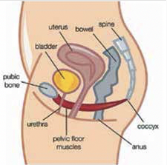
This factsheet will help you to exercise and strengthen your pelvic floor muscles. These muscles form a sling from the front to the back of the pelvis and provide support to the organs within it. They also play a role in controlling your bladder, bowel and sexual functions.

The basic exercise
Sit comfortably with your knees slightly apart and imagine that you are trying to stop yourself from passing urine or wind. The feeling is one of ‘squeeze and lift’ or a drawing together of the front and back passages. You should be able to feel the muscle move (a movement pulling away from your chair). Your legs and buttocks should not move and you should not hold your breath.

There are two variations of this basic exercise that you need to do to strengthen and improve the function of your pelvic floor muscles: slow and fast contractions.

Slow contractions
While sitting comfortably, tighten your pelvic floor muscles as hard as you can. Count to see how long you can hold this position for before the muscle starts to relax. Aim for a count of ten if possible.

How many seconds can you hold this position for?

Relax for a few seconds and then repeat this exercise as many times as you can (up to ten times). How many times can you repeat this exercise?

Fast contractions
Sit comfortably with your knees slightly apart. Tighten your pelvic floor muscles as quickly as you can and let go straight away.
Count how many fast contractions you can do in a row before your muscles become too tired to continue. How many fast contractions can you do?

Your exercise prescription
Each time you exercise you should perform:
slow contractions each one held for seconds (with a similar rest between each one).
Then you should perform fast contractions.
This exercise regime should be practised three times each day.

The knack technique
Tighten your pelvic floor muscle before and during these activities:
• coughing
• sneezing
• laughing
• picking something up
This is known as the ‘knack technique’ and can be used to reduce strain on your pelvic floor muscles and prevent leakage of urine.
Other things that may help
- Maintain your optimum weight
- • Avoid constipation
- Avoid heavy lifting
- Reduce your caffeine intake

How long will it take for the muscles to improve?
If you do your exercises regularly you should see some improvement in three to six months. Some people may notice an improvement after six weeks.
Remember, pelvic floor muscle exercises are for life and your symptoms may return if you stop doing them. Training should become part of your daily routine.

Further information or advice
If you require any further information or advice during your pregnancy, or following the birth of your baby, please contact your Midwife in the first 10 days or your GP or Health Visitor after this time.

Pelvic Floor Exercises A Quick Reference Guide:

Imagine you are about to pass wind and you want to stop yourself. You will clench the muscles inside you to try and stop it. That is how you squeeze your pelvic floor but you must keep breathing!

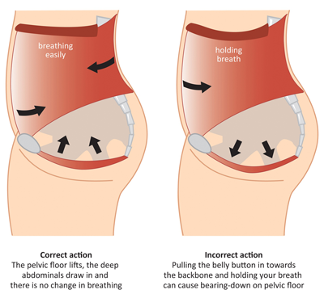

Practice as often as you can – do a set of long and short squeezes 3 times a day if you can, or as often as you remember.

Long squeeze – count how long you can hold for. 10 long squeezes held for up to 10 seconds is ideal.

Short squeeze – a short sharp squeeze of the muscle. See how many of these you can do before you get tired.

Getting the knack- tighten or squeeze the muscle every time you are going to cough/sneeze/ jump/ lift something heavy.

