Your child has been treated under the general paediatric team. They are fit to return home at this stage. Please continue to monitor your child at home, they are expected to continue to improve. We do not expect children to become worse following discharge.
If your child’s condition is getting worse or you are worried, please contact us over the next 48 hours on 01633 493949 or the open access phone numbers given to you. Your child may need a second clinical assessment. Nursing and medical staff cannot give specific advice over the telephone but will inform you what to do if you are worried or your child needs further clinical assessment.
After 48 hours you are likely to be redirected to 111/ GP services or the Emergency Department. If you contact any of these services, please explain your child was recently discharged from hospital.
Features to watch for at home following discharge:
- Laboured/rapid breathing or working hard to breathe, drawing in of the muscles below their lower ribs, at their neck or between their ribs (recession)
- A harsh breath noise as they breathe in (stridor) present only when they are upset
- Seems dehydrated and not passing urine for 12 hours
- Drowsiness (excessively sleepy)
- Ongoing abdominal pain especially if associated with fever and generally unwell
If you see any of the following features your child will need urgent help and please call 999:
- Breathing difficulties, e.g. has pauses in their breathing (apnoeas); or an irregular breathing pattern or grunting; has a harsh breath noise as they breathe in (stridor) present all of the time (even when they are not upset) or is too breathless to talk / eat or drink
- Going blue around the lips
- Becomes pale, mottled, or feels abnormally cold to touch
- Has a fit/seizure
- Becomes extremely agitated (crying / very unsettled and cannot be comforted) or becomes confused
- Is very lethargic (difficult to wake)
- Develops a rash that does not disappear with pressure (the glass test)
- Is under 1 month of age with a temperature of 38.0 C or above
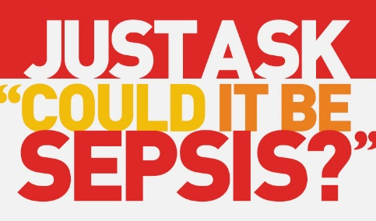
bit.ly/sepsis-trust

