
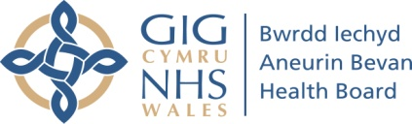

The Monmouthshire Early Help Panel
(Single Point of Access for Children’s Emotional Wellbeing)

What is the Monmouthshire Early Help Panel?

The SPACE-Wellbeing panel is a meeting from which professionals and families can seek early intervention and support for children’s mental health and emotional wellbeing.

The panel aims to make sure that families get the right service, first time, at the right time, and that services work in a joined-up way. Requests for support may be allocated to service to provide direct support to children and their families. Sometimes, requests for support will be allocated for ‘support in’. This means that specialist clinical staff who are part of the panel will link up with childcare professionals who are already working with the child to offer them support and guidance.

Who is part of Monmouthshire Early Help Panel?

The membership of the panel In Monmouthshire is:

- Aneurin Bevan University Health Board Primary Care Mental Health Support Service
- Families First – Building Strong Families
- Face 2 Face Therapy Services
- Changing Minds Project
- The Acorn Project
- Flying Start
- Home Start
- Inspire
- Housing
- Youth Service
- Young Carers
- Education
- Specialist CAMHS (routine referrals)
- Community Psychology
- Peer Support
- Community Family Intervention
- Housing
- Women’s Aid
- Platfform 4YP

How do I Request Support?

- Professionals or families can request support from the Monmouthshire Early Help Panel

- Informed consent must have been gained from a person with parental responsibility, and/or the young person where appropriate. Consent may be given verbally

- To access the Monmouthshire Early Help Panel the request for support from should be completed. This can be accessed by contacting the Early Help Co-ordinator on 01633 644152. Completed forms should be sent to: Earlyhelppanel@monmouthshire.gov.uk

- Information on the form will be stored on the Local Authority database and used for the purpose of providing services to children, young people and their families.

- If you have any queries please contact the Monmouthshire Early Help Co-ordinator on 01633 644152

