

Patient name

DOB

Hospital number

Please affix label

**Paediatric Sepsis 6**

Date/Time:

Is the child **unwell**? **PEWS concerns**?

**THINK** Could this be **Sepsis**……

**Child at risk:**

Core temperature <36°C or >38.5°C

Tachycardia (refer to PEWS)

Altered mental state (sleepy, irritable, floppy)

Excessively dry nappies (≤1/24hrs)

Prolonged Capillary refill >2secs

Parental concerns

**Source of infection:**

|  |  |
| --- | --- |
| Primary source unclear | Surgical site |
| Meningitis/encephalitis | VP shunt |
| Febrile neutropenia | Urinary infection |
| Line infection | LRTI/ Chest source |
| Intra-abdominal  Post Chicken Pox (strep) | Other: |

**RED FLAG SIGNS:**

|  |  |
| --- | --- |
| Hypotension (Systolic <2 SD for age – as below) |  |
| Lactate > 2mmol/l |  |
| Extreme Tachycardia/tachypnoea (below) |  |
| SpO2 <90%/grunting/cyanosis/Apnoea |  |
| P or U on AVPU |  |
| Immunocompromised |  |
| Non-blanching rash/ mottled skin |  |

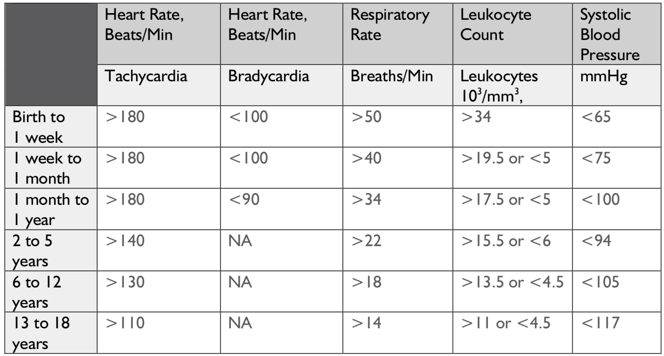



[This Photo](http://commons.wikimedia.org/wiki/File:Red_flag_waving_transparent.png) by Unknown Author is licensed under [CC BY-SA](https://creativecommons.org/licenses/by-sa/3.0/)



[This Photo](http://commons.wikimedia.org/wiki/File:Red_flag_waving_transparent.png) by Unknown Author is licensed under [CC BY-SA](https://creativecommons.org/licenses/by-sa/3.0/)

**OR**

Suspected or proven infection AND ≥ 2 signs of a Child at risk **OR** Any 1 RED Flag signs -

**CONSULT a Doctor Or ANP….**

|  |
| --- |
| All Components below to be delivered in **First hour:** (**Document Any Variance**) Done Time started |
| Tier 1 doctor (SHO) called: |
| Tier ≥2 doctor (Registrar/ Consultant) called: |
| 1. High flow oxygen given: |
| 1. IV/IO access obtained (**CULTURE, LACTATE,** **GLUCOSE**, FBC, U&E, CRP): |
| 1. Antibiotics given (<3m - Cefotaxime + Amoxicillin, >3m – Cefotaxime/Ceftriaxone): |
| 1. Fluid bolus, over 5-10mins (20ml/kg Hartmann’s or Plasmolyte 148, if no DKA or Renal disease): |
| * 1. 1st Bolus (All Obs, including BP Repeat every 30mins): |
| * 1. 2nd Bolus (Draw up Adrenaline, Start infusion after 2nd bolus, Escalate care): |
| * 1. 3rd Bolus (Give if no fluid overload/pulmonary oedema, and ongoing shock): |
| 1. Peripheral Adrenaline (Start after 2nd bolus, <https://www.watch.nhs.uk/drug-sheet>): |
| 1. Senior attendance - |
| * 1. Consultant paediatrician: |
| * 1. Anaesthetist support (+/- intubation, Discuss with WATCh, PICU transfer): |
|  |

**High suspicion of Sepsis or septic Shock Start Sepsis 6 and escalate care promptly:**

v

v

v

v

v

v

v

v

v

v

v

v

v

v

v

v

v

v

**If NOT Sepsis document reasons, if unsure REVIEW in 1HOUR, Repeat Obs Every 30mins**